
PERIODIC TEST 1 (2023-24)
Subject: PHYSICS MARKING SCHEME  Grade: XII |  | Max. Marks: 35  Time: 1Hour 20 Mins
Name: |  | Section: |  |  | Roll No:
 | SECTION- A
1 | d)-1Q and -1Q |  |  |  |  | 1
2 | c)a torque, but no net force |  |  |  |  | 1
3 | b)Electric Flux |  |  |  |  | 1
4 | c) Equal to 25N/C |  |  |  |  | 1
5 | c) 300 Q downwards |  |  |  |  | 1
6 | Ans: a |  |  |  |  | 1
7 | Ans:d |  |  |  |  | 1
8 | .Ans:a |  |  |  |  | 1
 | SECTION- B
9. | 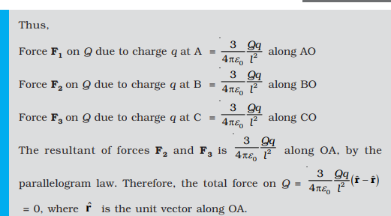 |  |  |  |  | 2
 | OR
 | 2a/3
10. | a) σ inside= -q/4πa2  b) σ outside= (Q+q)/4πb2 |  |  |  |  | 2
11. | Diagram  reason |  |  |  |  | 2
12. | a)B b) C  c) dipole A AND D |  |  |  |  | 2
13. | 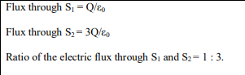 |  |  |  |  | 2
 | SECTION -C
14 | 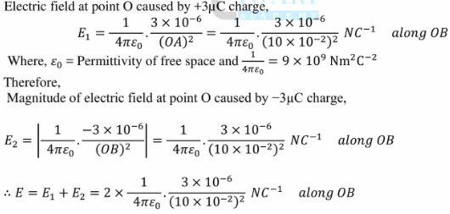  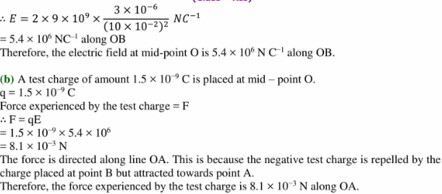 |  |  |  |  | 3
 |  |  |  |  |  | 3
15 | 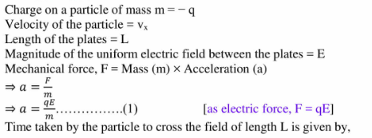  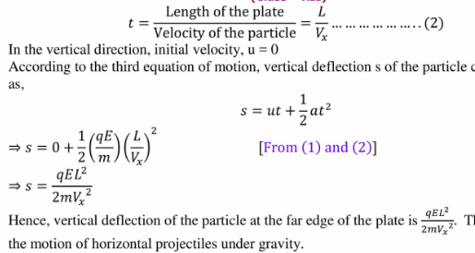 |  |  |  |  | 3
 | OR
 | 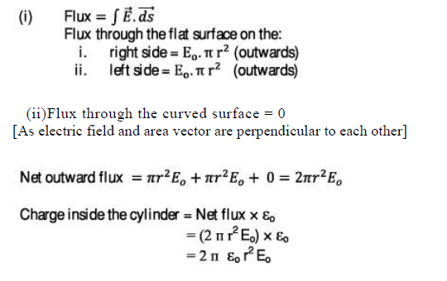
16 | 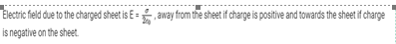  EA=- σ/2eo |  |  |  |  | 3
17. | Diagram 1/2  Proof 2  Vector form 1/2 |  |  |  |  | 3
 | SECTION -D
18. | a) State Gauss’s law in electrostatics. 1/2  Diagram 1  proof.2 1/2 |  |  |  |  | 5
B) | 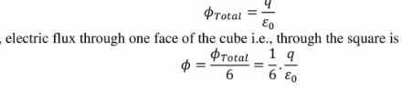 |  | 1
 | OR
 | - Diagram 1  Proof 3  b)180 |  |  |  |  | 5
**************************

